Men’s Health Awareness Month: Social Media Posts
Text | Image
Let’s Get Men Talking this November!  For #MensHealthAwarenessMonth, here’s how you can protect yourself from cancer & other conditions.  Get to know your body and take part in screening & health checks when invited. Seek help if you have any concerns.  www.answercancergm.org.uk/cancer-screening | 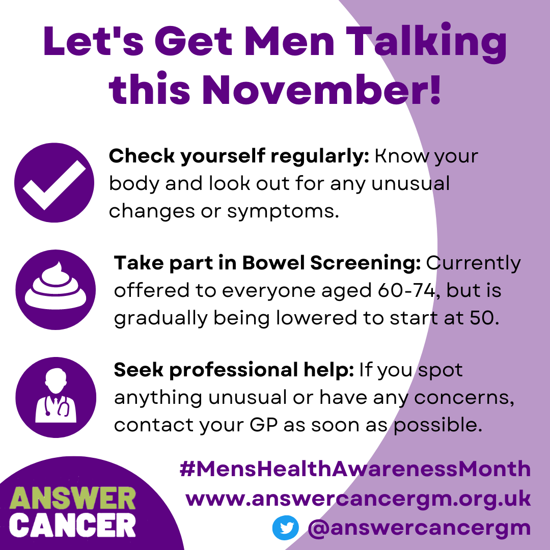
Let’s Get Men Talking this November!  For #MensHealthAwarenessMonth, here’s everything you need to know about bowel cancer screening. This includes:  - when you’ll be invited  - what’s involved  - why it’s so important  www.answercancergm.org.uk/cancer-screening | 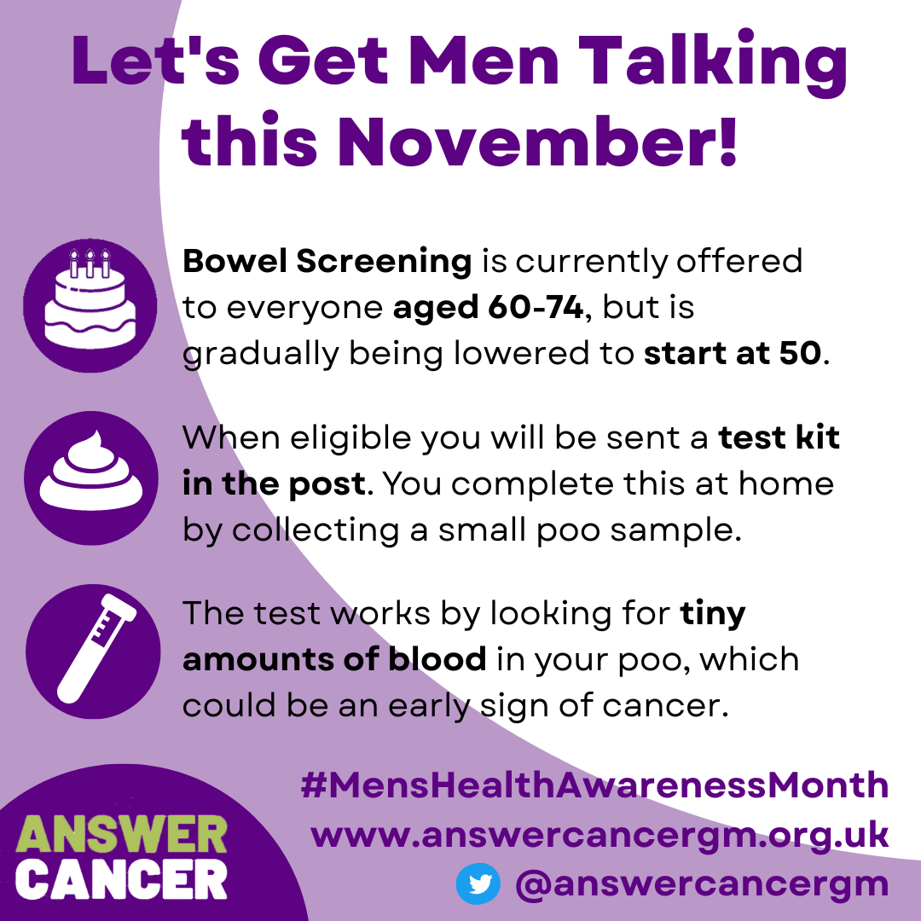
Let’s Get Men Talking this November!  For #MensHealthAwarenessMonth, here are a few ideas of how you can help protect your friends, family and community from health conditions such as cancer.  Have conversations, share information & get involved!  www.answercancergm.org.uk | 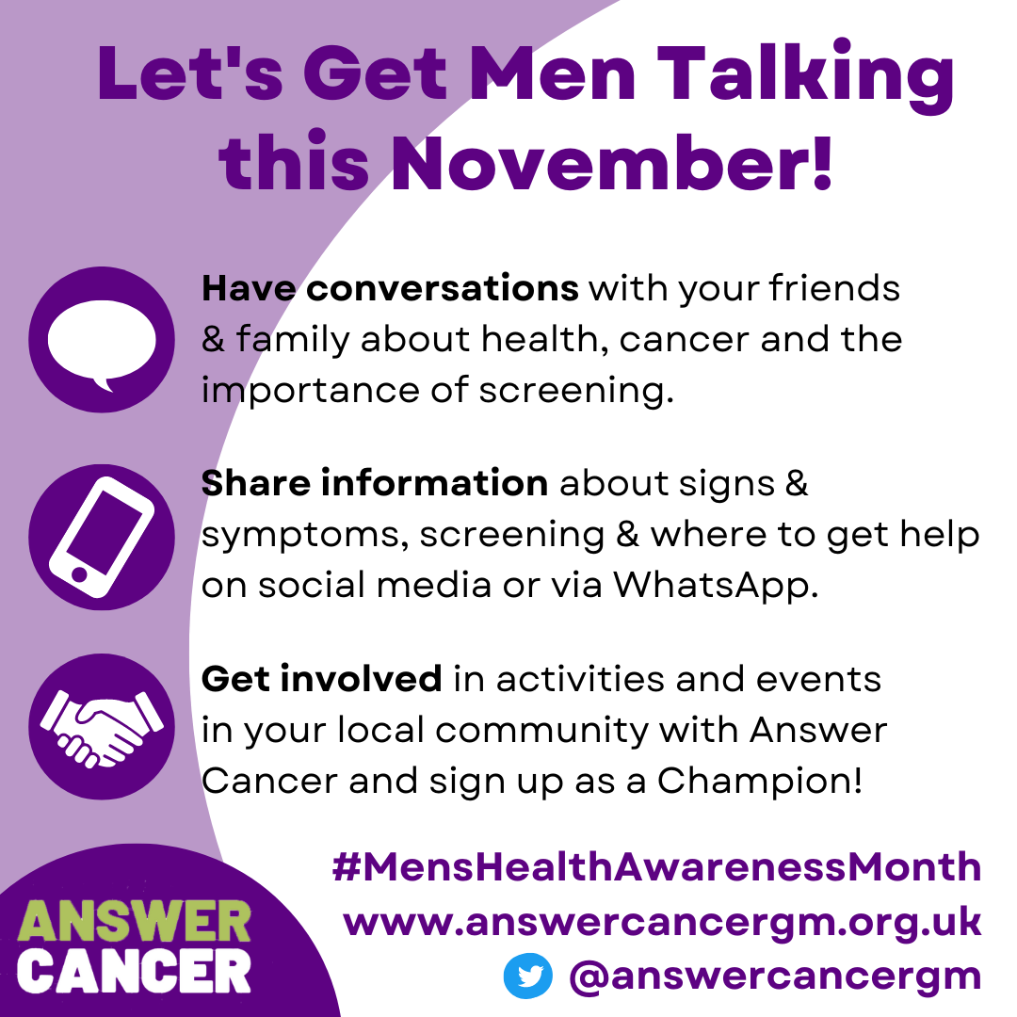
Let’s Get Men Talking this November!  Our #MensHealthAwarenessMonth event For The Lads takes place on 22nd November at @SalfordCVS.  This will cover bowel & prostate cancers. We will discuss signs & symptoms and the importance of early detection.  Book here: https://www.eventbrite.co.uk/e/answer-cancer-for-the-lads-bowel-and-prostate-cancer-awareness-tickets-400814616307 | 