Cervical Cancer Prevention week: Social Media Posts
Text | Image Alt Text | Image
This #CervicalCancerPreventionWeek, let’s spread the word about #CervicalScreening!  Screening helps to prevent cancer by detecting changes in their early stages.  It is available to women & anyone with a cervix aged 25-64, and takes place every 3-5 years.  www.answercancergm.org.uk/cancer-screening | Let’s Beat Cervical Cancer!  Cervical screening can help to prevent cancer by detecting changes in their early stages.  The screening 'smear test' is offered to women and anyone with a cervix aged 25-64.  Everyone eligible is invited every 3 years until aged 49, and then every 5 years from 50-64.  #CervicalCancerPreventionWeek  www.answercancergm.org.uk  Twitter: @answercancergm | 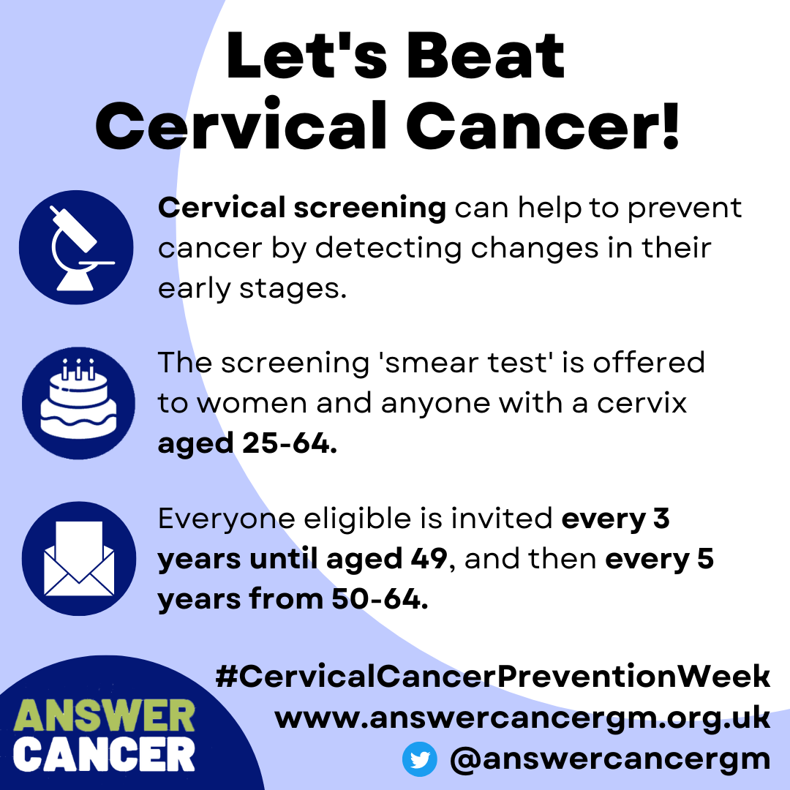
Together we can beat cervical cancer!  - Cervical Screening helps to prevent cancer by detecting changes early.  - The HPV Vaccine protects against the virus which causes 99% of cervical cancers.  - Help raise awareness by sharing this message for #CervicalCancerPreventionWeek! | Let’s Beat Cervical Cancer!  Cervical Screening: Available to women and anyone with a cervix aged 25-64. It can detect early changes before they develop into cancer.  HPV Vaccine: Offered to boys & girls aged 11-13, this protects against the virus which causes over 99% of cervical cancers.  Raise Awareness: Have conversations with friends & family and share information via social media & WhatsApp.  #CervicalCancerPreventionWeek  www.answercancergm.org.uk  Twitter: @answercancergm | 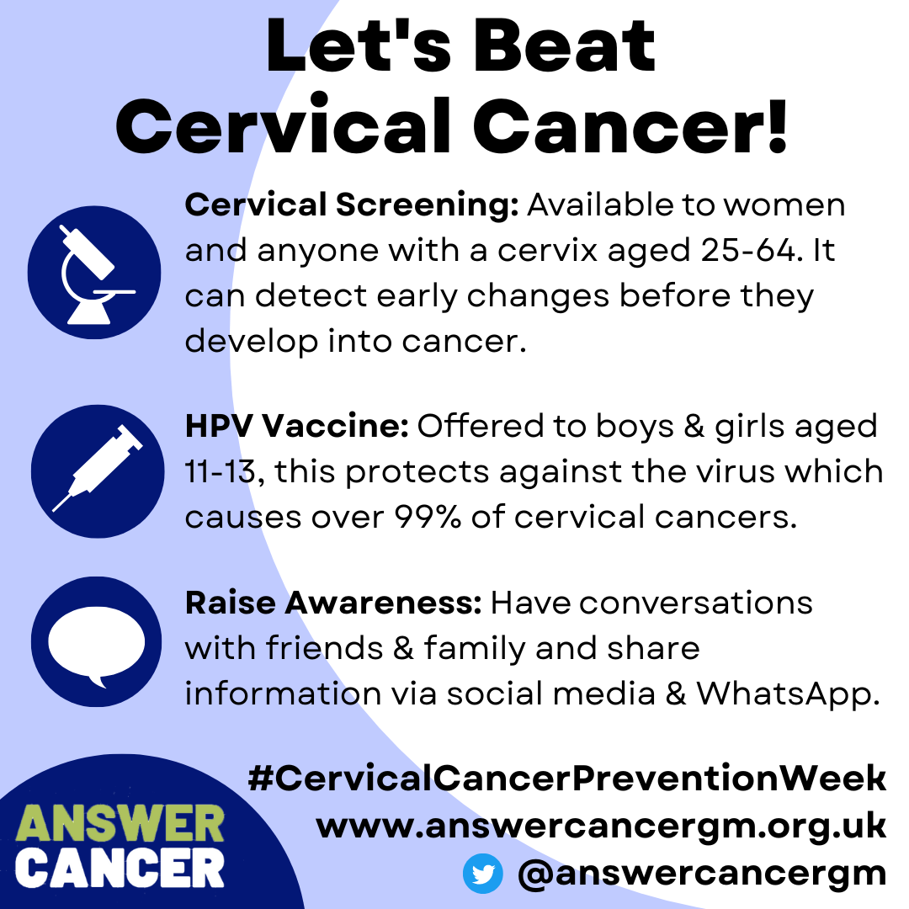
Let's beat cervical cancer!  For #CervicalCancerPreventionWeek, here are a few ideas of how you can help protect your friends, family & community.  - Have conversations about health & cancer  - Share information from trusted sources  - Become an AC Champion!  www.answercancergm.org.uk/ | Let’s Beat Cervical Cancer!  Have conversations with your friends & family about health, cancer and the importance of screening.  Share information on social media or via WhatsApp about the HPV Vaccine, screening & where to get advice.  Get involved in activities and events in your local community with Answer Cancer and sign up as a Champion!  #CervicalCancerPreventionWeek  www.answercancergm.org.uk  Twitter: @answercancergm | 