Breast Cancer Awareness Month: Be Breast Aware Social Media Posts
Title | Text | Image
Symptoms | Be Breast Aware this #BreastCancerAwarenessMonth!  Make sure you know the possible signs & symptoms of breast cancer and check yourself regularly!  Contact your GP if you have any concerns and always take part in breast screening when you’re invited.  www.answercancergm.org.uk/cancer-screening | 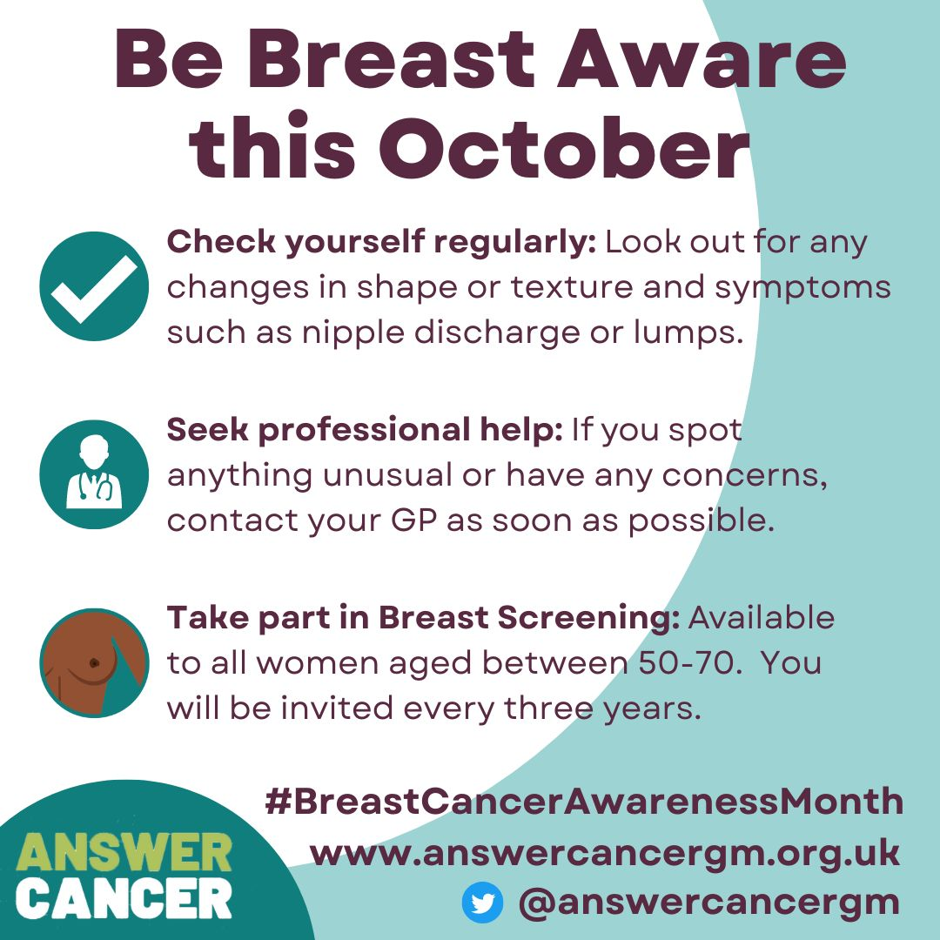
TLC | Be Breast Aware this #BreastCancerAwarenessMonth.  Keep yourself safe from breast cancer by performing regular self-examinations. Give yourself some TLC!  Contact your GP if you have any concerns and always take part in breast screening when you’re invited  www.answercancergm.org.uk/cancer-screening | 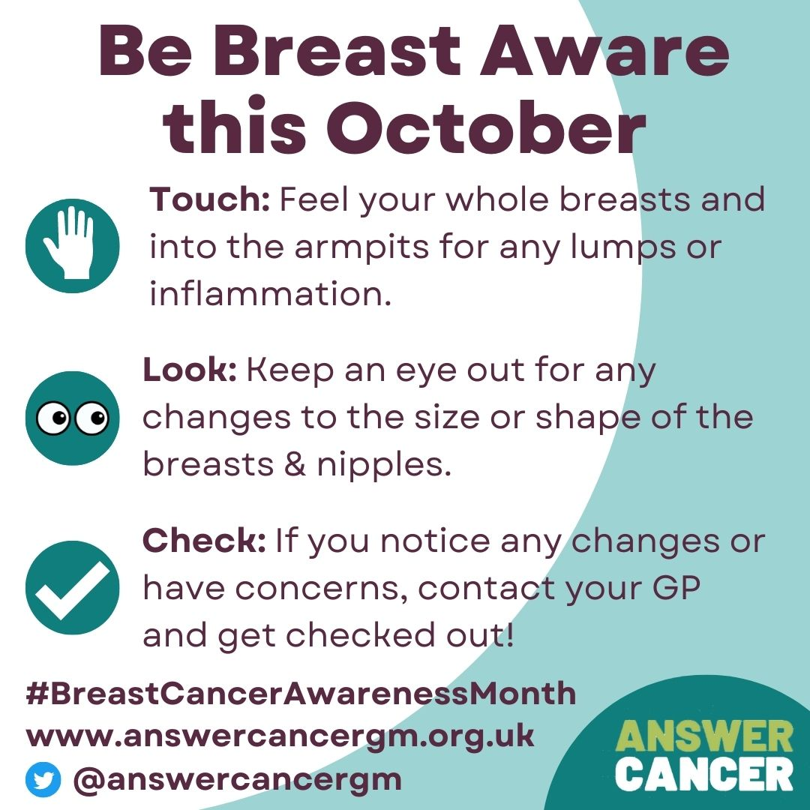
Screening | Be Breast Aware this #BreastCancerAwarenessMonth.  Breast Screening is offered by the NHS and, along with regular self-examinations, is the best way to keep you safe from breast cancer.  Always contact your GP if you have any concerns between screenings.  www.answercancergm.org.uk/cancer-screening | 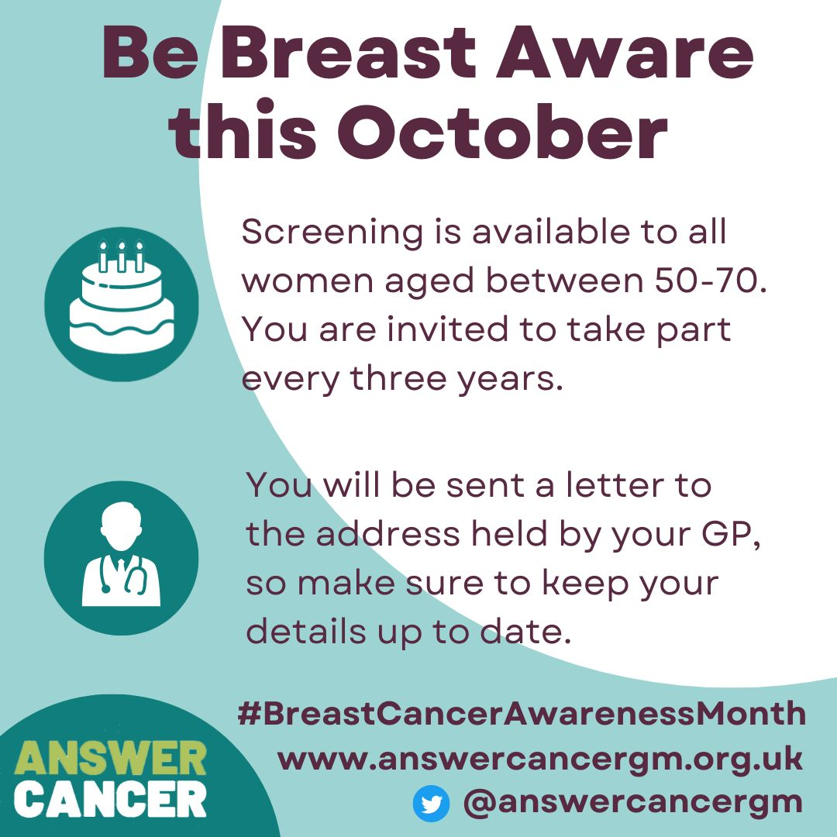
Actions | Be Breast Aware this #BreastCancerAwarenessMonth.  Here are a few ideas of how you can get involved during October and help protect your friends, family and community from Breast Cancer.  www.answercancergm.org.uk/cancer-screening | 